- Reduced methane oxidizing activity by sediment methanotrophs in shallow coastal zones with high methane emissions

- Elias Broman, Xiaole Sun, Christian Stranne, Marco G. Salgado, Stefano Bonaglia, Marc Geibel, Alf Norkko, Christoph Humborg, Francisco J.A. Nascimento

Additional Information figures
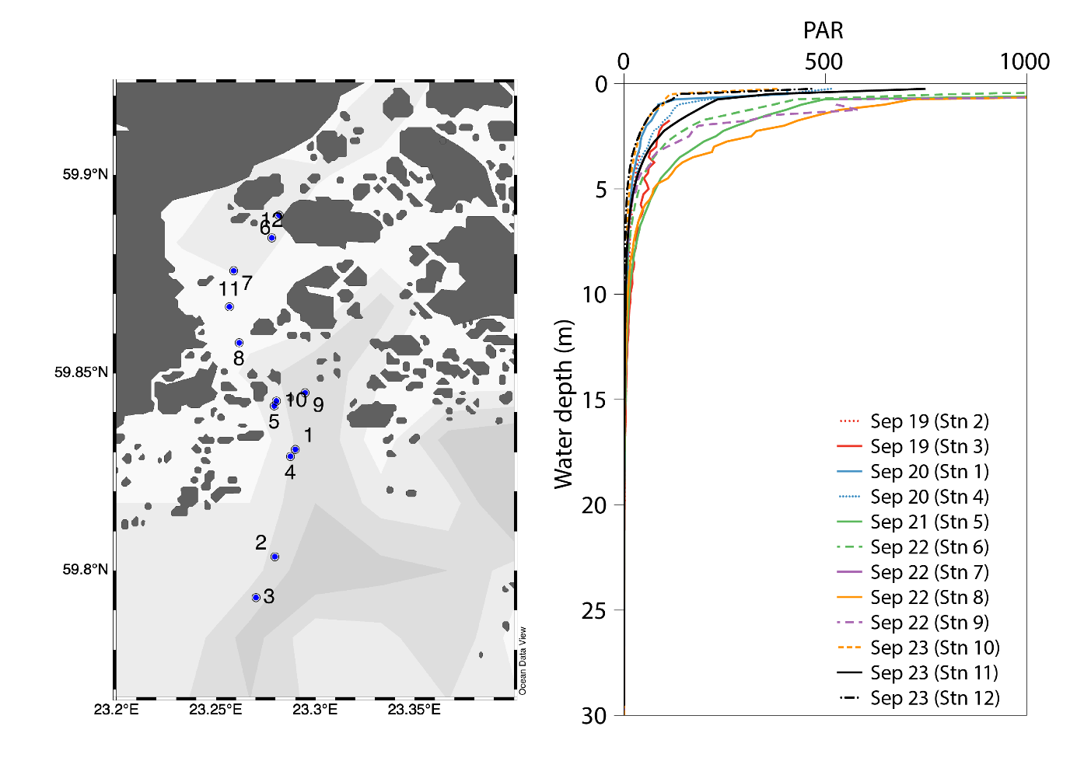
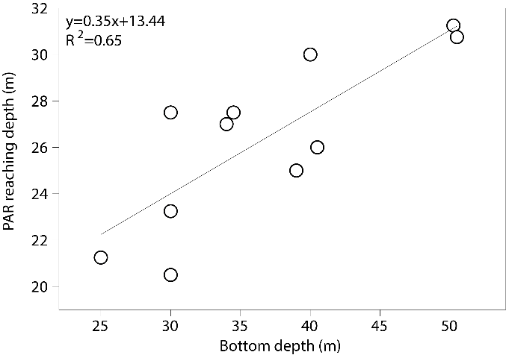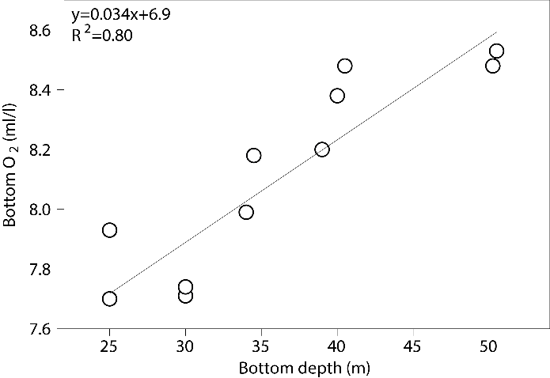
Figure S1 Top panel: CTD profiles from 12 locations inside the Storfjärden bay (note that CTD station numbers and not related to the station numbers were sediment was collected). PAR light profiles were collected during the 2018 sampling campaign between 19–23 September. Bottom left panel: Water depth vs the depth PAR is measured to be 0. Bottom right panel: Water depth vs oxygen concentrations in the bottom water. Station 5 is not shown in bottom panels as PAR never reached 0.

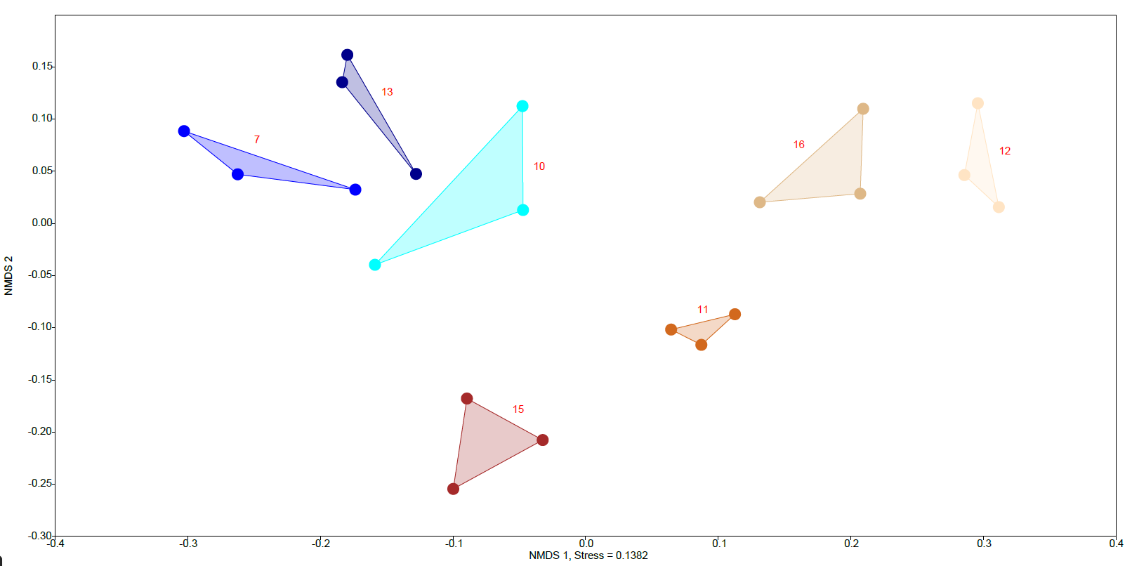
Figure S2 NMDs showing the Bray-Curtis beta diversity of all samples (2018 16S rRNA gene DNA data). Station names are indicated next to their cluster of data points (n = 3 per station).

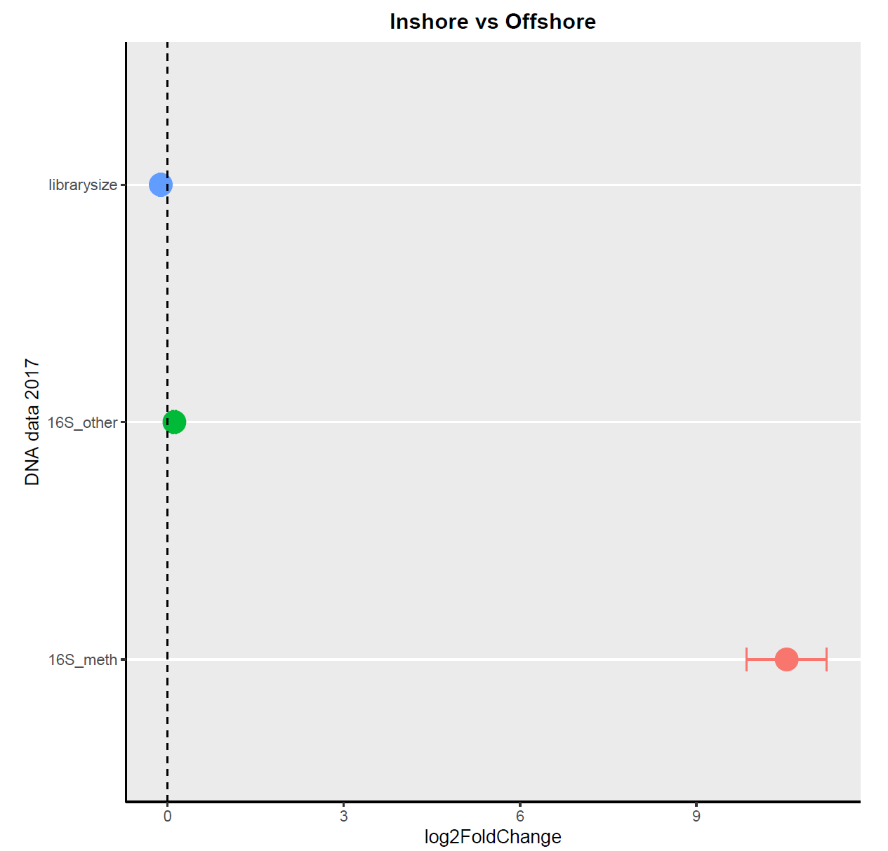
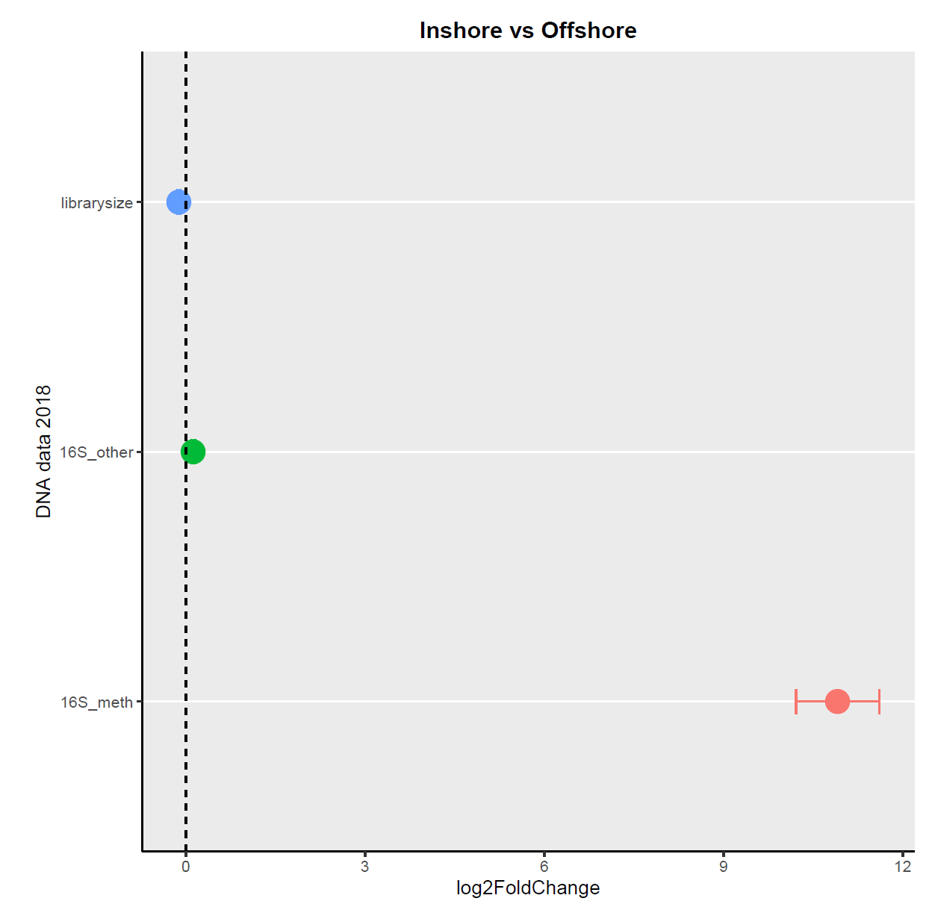
Figure S3 Results from DESeq2 analysis testing the difference between inshore (left side of dashed line) and offshore stations (right side of dashed line). The data was based on counts attributed to Methylococcales 16S rRNA gene sequences (red, denoted as 16S_meth on y-axis), all other 16S rRNA gene sequences (green, denoted as 16S_other on y-axis), and the total library size of the DNA metagenome samples (blue). The top panel shows data for 2017, and the bottom panel shows data for 2018. The error bars show SE.
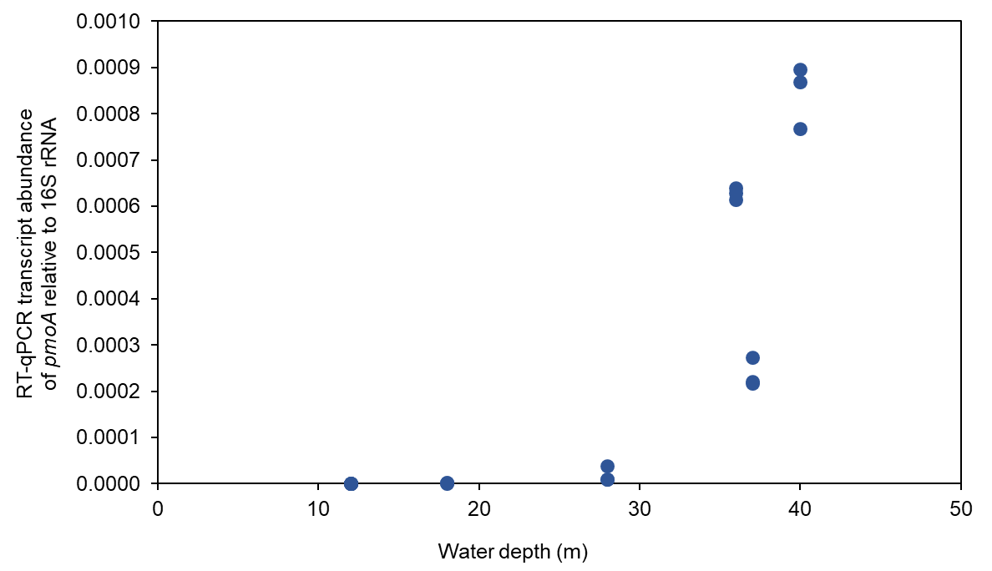
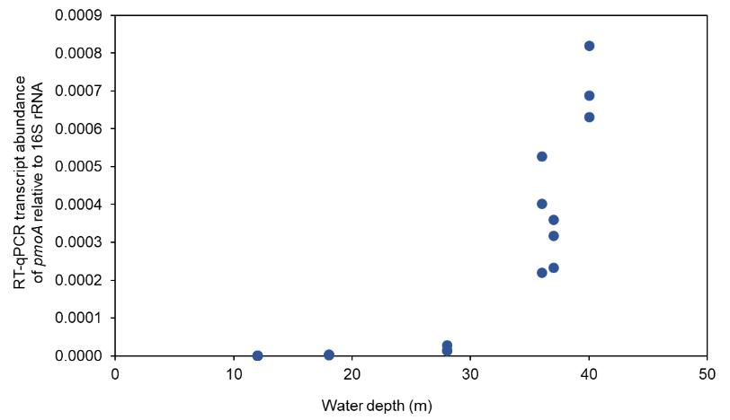
Figure S4 RT-qPCR results showing the number of pmoA RNA transcripts relative to 16S rRNA for each station along the water depth gradient (y-axis shows NRQ; normalized relative quantification). The data is based on the designed pmoA primer pairs:
Top panel: pmoA_1700181_5_Fw - pmoA_1700181_5_Rv
Bottom panel: pmoA_13667928_2_Fw - pmoA_13667928_2_Rv
The primer names are based on the prodigal contig names (Data S3).
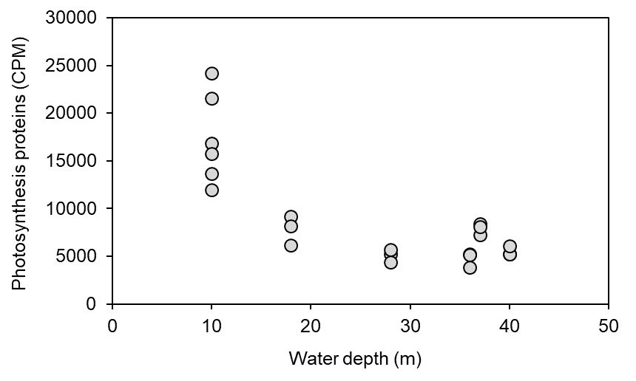
Figure S5 The graph shows RNA transcripts attributed to proteins in the GO category photosynthesis (y-axis, CPM-values). The x-axis shows the water depth (m) in the studied stations.

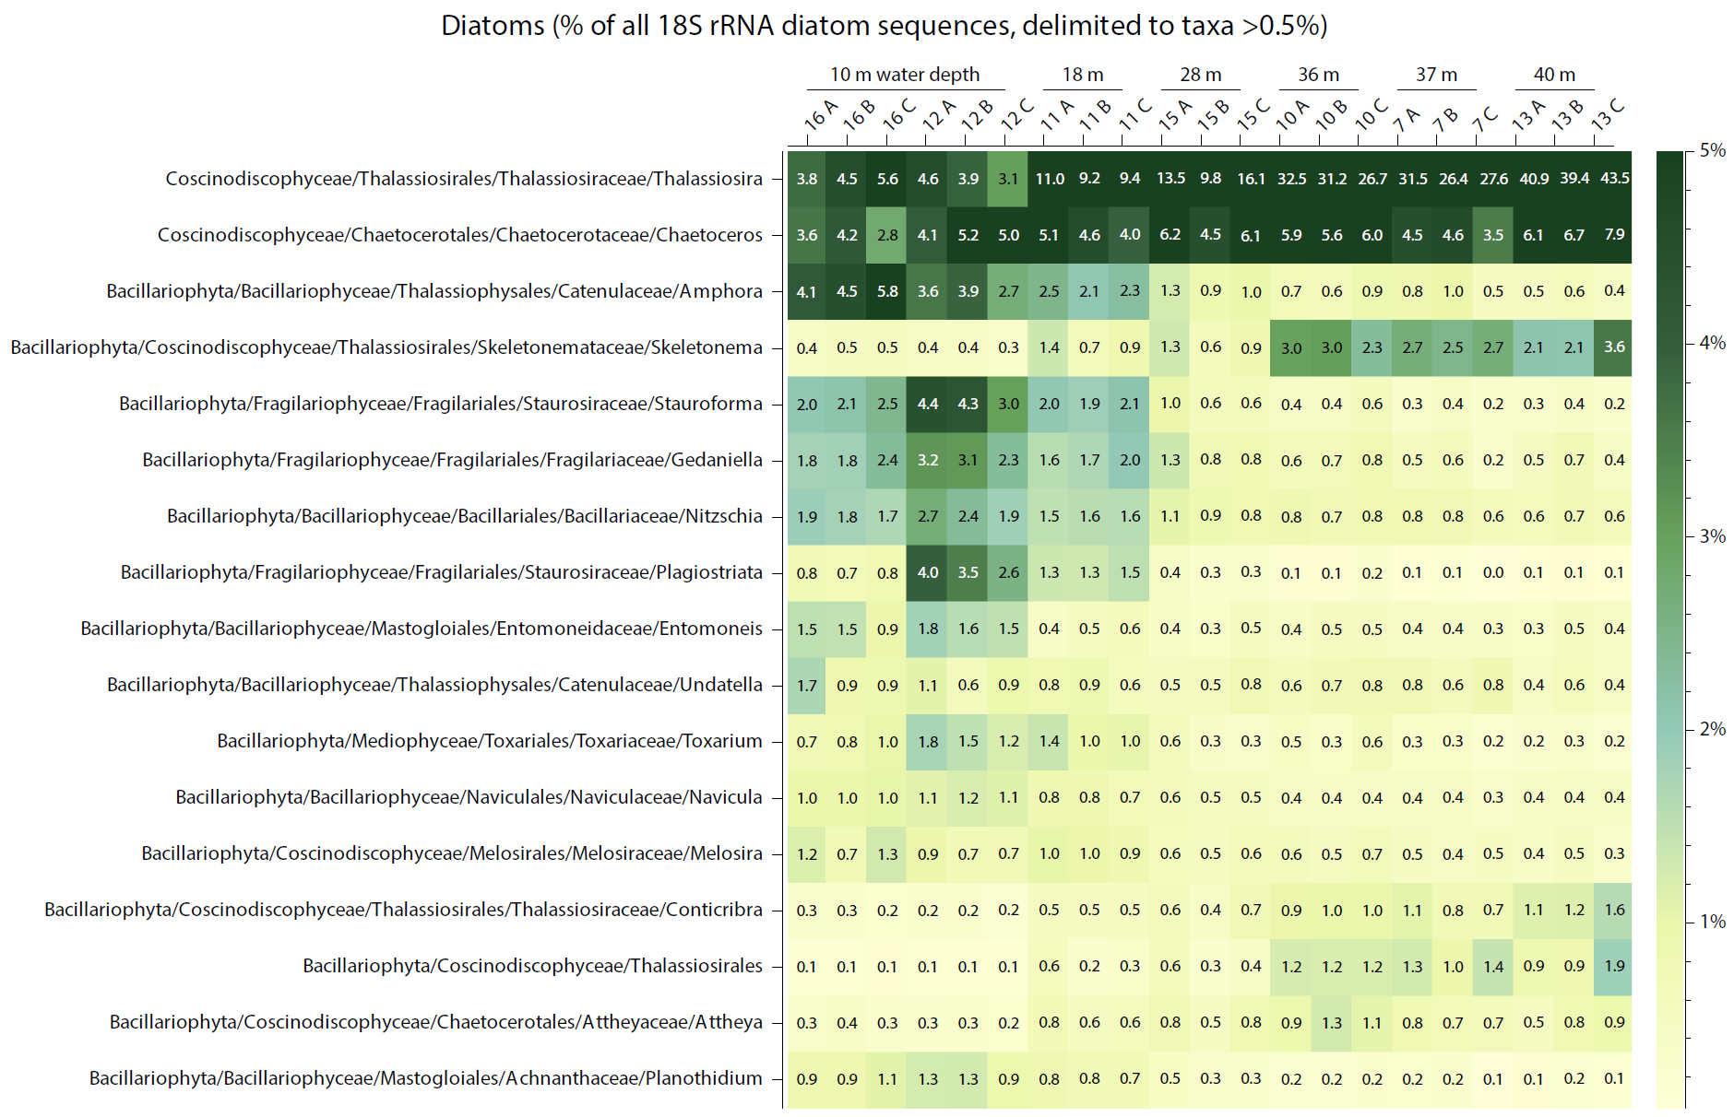

Figure S6 Relative abundance of 18S rRNA sequences belonging to diatoms. The colour gradient and numbers in the heatmap shows the % per taxa compared to the whole diatom community. The heatmap only shows taxa with a total average > 0.5%.

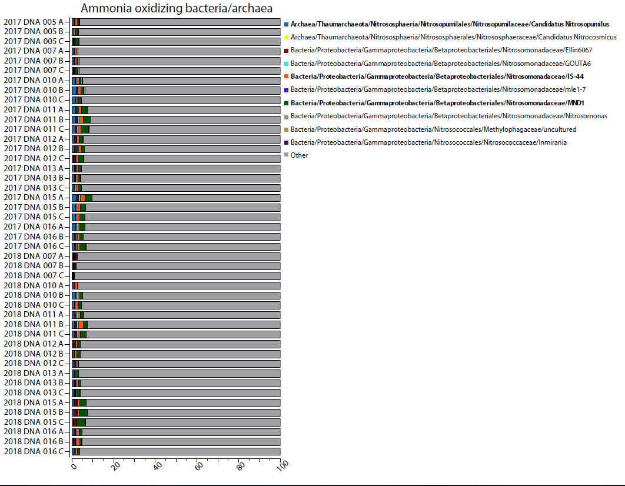
Figure S7 The relative abundance of ammonia oxidizing bacteria. The x-axis shows the relative abundance (%) of the whole microbial community. Groups with a high relative abundance are indicated by bold text. The group “other” (denoted by grey colour) shows denotes all other prokaryotes.
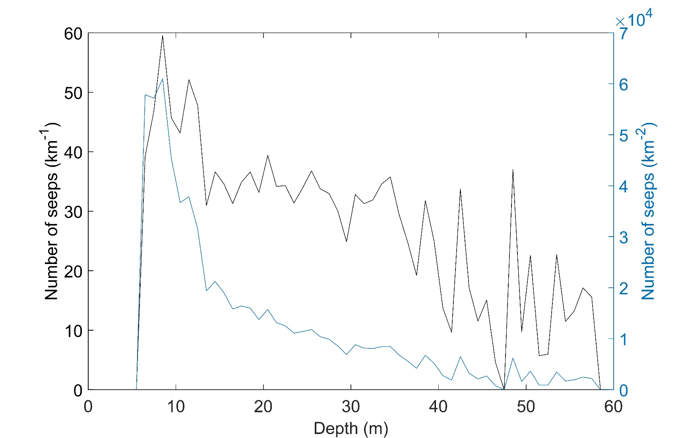
Figure S8 Depth plotted against number of seeps per km (left y-axis) and against number of seeps per km2 (right y-axis).

